#wget <https://www.keepalived.org/download.html>

<https://blog.csdn.net/bbwangj/article/details/80346428>

将keepalived安装成Linux系统服务

因为没有使用keepalived的默认路径安装（默认是/usr/local）,安装完成之后，需要做一些工作

复制默认配置文件到默认路径

# mkdir /etc/keepalived

# cp /usr/local/keepalived/etc/keepalived/keepalived.conf /etc/keepalived/

复制keepalived服务脚本到默认的地址

# cp /usr/local/keepalived/etc/rc.d/init.d/keepalived /etc/init.d/

# cp /usr/local/keepalived/etc/sysconfig/keepalived /etc/sysconfig/

# ln -s /usr/local/keepalived/sbin/keepalived /usr/sbin/

# ln -s /usr/local/keepalived/sbin/keepalived /sbin/

设置keepalived服务开机启动

# chkconfig keepalived on

/etc/keepalived/haproxy_check.sh

|  |
| --- |
| #!/bin/bash  START_HAPROXY="/etc/rc.d/init.d/haproxy start"  STOP_HAPROXY="/etc/rc.d/init.d/haproxy stop"  LOG_FILE="/usr/local/keepalived/log/haproxy-check.log"  HAPS=`ps -C haproxy --no-header |wc -l`  date "+%Y-%m-%d %H:%M:%S">> $LOG_FILE  echo "check haproxy status">> $LOG_FILE  if [ $HAPS -eq 0 ];then  echo $START_HAPROXY >> $LOG_FILE  $START_HAPROXY >> $LOG_FILE 2>&1  sleep 3  if [ `ps -C haproxy --no-header |wc -l` -eq 0 ];then  echo "start haproxy failed, killall keepalived">> $LOG_FILE  killall keepalived  fi  fi |

/etc/keepalived/keepalived.conf

|  |
| --- |
| ! Configuration File for keepalived  global_defs {  notification_email {  acassen@firewall.loc  failover@firewall.loc  sysadmin@firewall.loc  }  notification_email_from Alexandre.Cassen@firewall.loc  smtp_server 192.168.200.1  smtp_connect_timeout 30  router_id LVS_DEVEL1  vrrp_skip_check_adv_addr  #vrrp_strict  vrrp_garp_interval 0  vrrp_gna_interval 0  }  vrrp_script check_haproxy {  script "/etc/keepalived/haproxy_check.sh"  interval 2  weight 2  }  vrrp_instance VI_1 {  state BACKUP  interface ens33  virtual_router_id 51  priority 120  nopreempt  advert_int 1  authentication {  auth_type PASS  auth_pass 1111  }  track_script {  check_haproxy  }  virtual_ipaddress {  192.168.2.16  }  }  virtual_server 192.168.200.100 443 {  delay_loop 6  lb_algo rr  lb_kind NAT  persistence_timeout 50  protocol TCP  real_server 192.168.201.100 443 {  weight 1  SSL_GET {  url {  path /  digest ff20ad2481f97b1754ef3e12ecd3a9cc  }  url {  path /mrtg/  digest 9b3a0c85a887a256d6939da88aabd8cd  }  connect_timeout 3  retry 3  delay_before_retry 3  }  }  }  virtual_server 10.10.10.2 1358 {  delay_loop 6  lb_algo rr  lb_kind NAT  persistence_timeout 50  protocol TCP  sorry_server 192.168.200.200 1358  real_server 192.168.200.2 1358 {  weight 1  HTTP_GET {  url {  path /testurl/test.jsp  digest 640205b7b0fc66c1ea91c463fac6334d  }  url {  path /testurl2/test.jsp  digest 640205b7b0fc66c1ea91c463fac6334d  }  url {  path /testurl3/test.jsp  digest 640205b7b0fc66c1ea91c463fac6334d  }  connect_timeout 3  retry 3  delay_before_retry 3  }  }  real_server 192.168.200.3 1358 {  weight 1  HTTP_GET {  url {  path /testurl/test.jsp  digest 640205b7b0fc66c1ea91c463fac6334c  }  url {  path /testurl2/test.jsp  digest 640205b7b0fc66c1ea91c463fac6334c  }  connect_timeout 3  retry 3  delay_before_retry 3  }  }  }  virtual_server 10.10.10.3 1358 {  delay_loop 3  lb_algo rr  lb_kind NAT  persistence_timeout 50  protocol TCP  real_server 192.168.200.4 1358 {  weight 1  HTTP_GET {  url {  path /testurl/test.jsp  digest 640205b7b0fc66c1ea91c463fac6334d  }  url {  path /testurl2/test.jsp  digest 640205b7b0fc66c1ea91c463fac6334d  }  url {  path /testurl3/test.jsp  digest 640205b7b0fc66c1ea91c463fac6334d  }  connect_timeout 3  retry 3  delay_before_retry 3  }  }  real_server 192.168.200.5 1358 {  weight 1  HTTP_GET {  url {  path /testurl/test.jsp  digest 640205b7b0fc66c1ea91c463fac6334d  }  url {  path /testurl2/test.jsp  digest 640205b7b0fc66c1ea91c463fac6334d  }  url {  path /testurl3/test.jsp  digest 640205b7b0fc66c1ea91c463fac6334d  }  connect_timeout 3  retry 3  delay_before_retry 3  }  }  } |

配置标颜色的需要注意。

**特别注意：如果非抢占模式不生效，在Keepalived的故障节点恢复后会再次导抢占vip，从而因vip切换而闪断带来的风险（视频解说）。按以上配置，配置了Keepalived非抢占模式，配置及注意点如下：**

(1)主设备、从设备中的state都设置为BACKUP

(2)主设备、从设备中都不要配置mcast_src_ip （本机IP地址）

(3)默认主设备（priority值大的Keepalived节点）配置一定要加上 nopreempt，否则非抢占不起作用

(4)防火墙配置允许组播（主、备两台设备上都需要配置，keepalived使用224.0.0.18作为Master和Backup健康检查的通信IP）

# iptables -I INPUT -i eth1 -d 224.0.0.0/8 -p vrrp -j ACCEPT

# iptables -I OUTPUT -o eth1 -d 224.0.0.0/8 -p vrrp -j ACCEPT

（eth1为主机的网卡设备名称，生产环境服务器可以用独立网卡来处理组播和心跳检测等）

# service iptables save

重启防火墙：

# service iptables restart

虚拟ip在192.168.2.133这个机器上

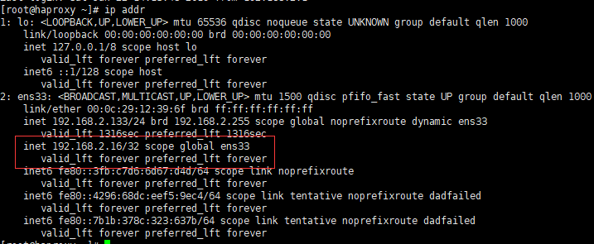

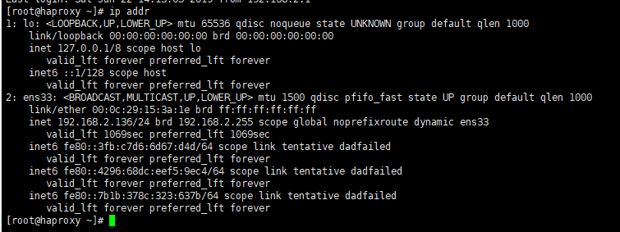

关掉133这个机器上的haproxy，虚拟ip到136这个机器上

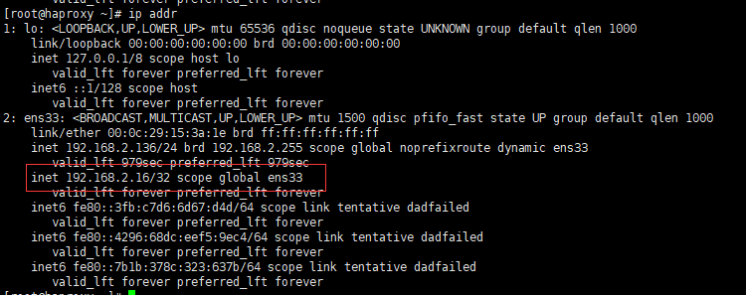

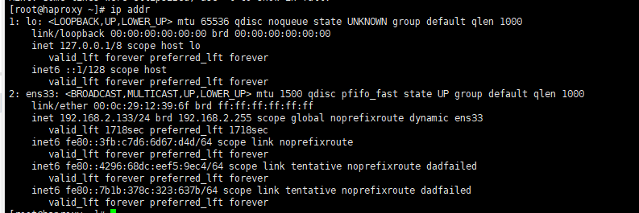

遇到问题，主要是防火墙

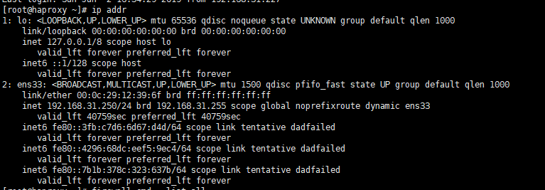

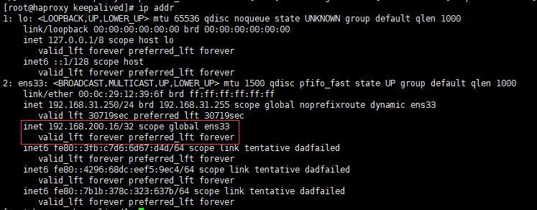

能ping通虚拟ip，本机也能通过虚拟ip访问mysql，

但是在其他机器不能登录也不能telnet（能ping通ip）

修改防火墙配置

sudo iptables -F